Linear Antenna Array

Assignment 1 : EEL 6935 - SPRING.2018 Hector Lopez 1-16-2018

# Problem 1

## Description

Consider the most trivial of all linear array processors that has beamformer weight values w_i = 1 for every i = 1,2...M assume that a unit-value signal (m(t)=1) on a carrier frequency fc is arriving at your antenna array with a direction of arrival theta. Assume inter-element spacing equal to half the carrier wavelength, d=lambda_c/2.Plot the array output |y|^2 in plain scale and in dB log-scale as a function of theta for M=3,5,10 (this is known as a power pattern or power beam pattern).

## Results

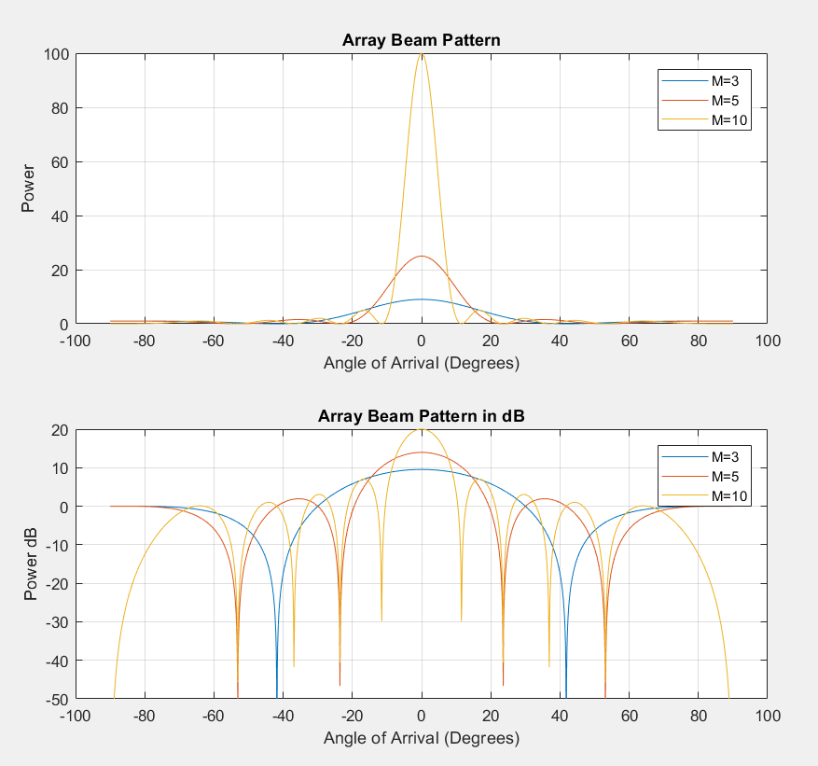

## Observations

1. The greater the number of antenna elements in the array means that the output signal will have a proportional amount of energy. This makes sense because the arriving signals are summed together to create the output signal.
2. The angle of arrival, theta, is at its peak when it is at 0 degrees. It would make sense that the most powerful output occurs when all the arriving signals are directly perpendicular to the linear antenna array. The output signal should be weakest at an angle of arrival of +/-90 degrees because that’s when the arriving signal is only coming hitting either the first or last antenna exclusively.
3. Nulls; The more antennas the more nulls across the array there are. Even at an optimum Nyquist distance from each antenna on the array there exists angles of arrival that would not be detected by the array. The more antennas the less those lobes filter out signals.
4. By having many antennas tuning can be used to change the filter configuration of the array.
5. An amplified power signal would allow for greater details being observed. If the arriving signal is the same signal at all the antennas, then greater antenna elements could be helpful in “cleaning” the signal and cross referencing it to reduce noise.

## Would an array with fixed unit weights be useful?

## This type of configuration may be useful in testing linear array elements. Confirming the overall response has not diminished could verify that the antennas are performing optimally. Another use would be to map the surrounding area around the array. In a perfect world all the arriving signals would be un-impeded but in the real world there could be terrain or obstacles that would change the strength of each arriving signal at different angles. A unit weight vector could be useful in detecting these obstacles.

## MATLAB Source Code

%% Linear Antenna Array Processor

% Hector Lopez EEL6935 SPRING2018

% Assignment 1

% Description:

% Given a linear array of antenna elements of sizes

% 3,5,and 10, plot the array beam pattern output y(theta)

% for arriving angle, theta ; -90 to 90 degrees. Plot

% a dB and linear scale.

%%

theta=-90:0.1:90;

Y_M3=processor(3,theta);

Y_M5=processor(5,theta);

Y_M10=processor(10,theta);

figure

close all;

subplot(2,1,1);

plot(theta,((abs(Y_M3).^2)), ...

theta,((abs(Y_M5).^2)), ...

theta,((abs(Y_M10).^2)));

grid on;

title('Array Beam Pattern');

legend('M=3','M=5','M=10');

xlabel('Angle of Arrival (Degrees)');

ylabel('Power');

subplot(2,1,2);

plot(theta,10*log10((abs(Y_M3).^2)), ...

theta,10*log10((abs(Y_M5).^2)), ...

theta,10*log10((abs(Y_M10).^2)));

ylim=[-50 20];

set(gca,'YLim',[-50 20])

grid on;

title('Array Beam Pattern in dB');

legend('M=3','M=5','M=10');

xlabel('Angle of Arrival (Degrees)');

ylabel('Power dB');

%% Processor(M,T)

% M=number of antenna elements in linear array

% theta= 1d vector, angles(degree) of arrival for incoming signal

function Y = processor(M,theta)

%carrier frequency

fc=2*10^9;

%speed of light

c=3*10^8;

%carrier wavelength

lambda_c =c/fc;

%optimum nyquist element spacing

D=0:1:M-1;

D=D*(lambda_c/2);

%wieghts

W=ones(M,1);

%arriving signal

m0=1;

%time

t=0;

Y=1:size(theta);

k=0;

for th = theta

k=k+1;

S=exp(-1i*pi*(D/lambda_c)*sind(th));

X=m0*exp(1i*2*pi*fc*t)*transpose(S);

Y(k)=sum(W'*X);

end

end

Problem 2

## Description

Design a beamformer with unit response at 60 degrees and nulls at 0, 30 and -75. Assume again d=lambda_c/2. How many elements are you using and why? Find your weight vector w and plot the power beam pattern in dB.

## How many elements should be used?

The minimum number of antenna elements would be 4. The 3 elements to null out the angles would be needed in the array response vector matrix while the 4th element would be used to protect the last angle.

## Math Operations

1. Find the weights vector by using the formula :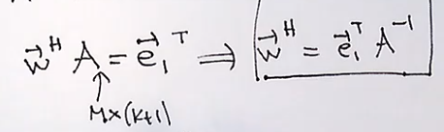
2. The weights are the product of the state array vector as a matrix for every theta that we desire to null out and the theta we want to protect as the first column of the matrix. The e vector is the vector designating the first column in A to be multiplied by a 1 and the others to be multiplied by 0. (see source code).
3. With the weights we can then run through the processor just as before. The processor needs to build a array response vector on each theta across the sweep of -90 to 90 degrees. Then each response vector at the given theta is used to calculate the output by summing the product of the input vector for each element and the weights we designed (see .2) .

## Results

As expected the weights have nulled out the angles of arrival that we designed against but kept the angle “60” as a protected angle for the incoming signals.

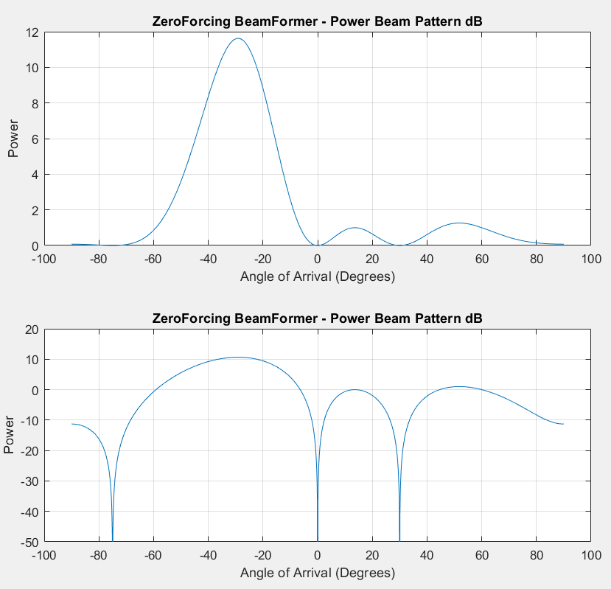

## MATLAB Source Code

%% ZeroForcing Beam Former

% Hector Lopez EEL6935 SPRING2018

% Assignment 1.b

M=4;

thetas = [60,0,30,-75];

d=0:1:M-1;

e=[1,0,0,0];

A = exp(-1i*2*pi*(d'/2)*sind(thetas));

w_H=e*inv(A);

w=ctranspose(w_H);

m0=1;t=0;fc=1;k=0;

Y=1:size(th_sweep);

th_sweep=-90:0.1:90;

for th = th_sweep

k=k+1;

S=exp(-1i*2*pi*(d'/2)*sind(th));

x=m0*exp(1i*2*pi*fc*t)*transpose(S);

Y(k)=sum(w_H.*x);

end

%Power Beam Pattern

P=abs(Y).^2;

P_dB=10*log10(abs(Y).^2);

%Plot Results

figure;

close all;

subplot(2,1,1);

plot(th_sweep,P);

grid on;

title('ZeroForcing BeamFormer - Power Beam Pattern dB');

xlabel('Angle of Arrival (Degrees)');

ylabel('Power');

subplot(2,1,2);

plot(th_sweep,P_dB);

ylim=[-50 20];

set(gca,'YLim',[-50 20])

grid on;

title('ZeroForcing BeamFormer - Power Beam Pattern dB');

xlabel('Angle of Arrival (Degrees)');

ylabel('Power');